PROGRAMMING ASSIGNMENT
PROG6212
WRITTEN BY
NTOKOZO SKOSANA
ST10476844
Link to Github: https://github.com/CodeCraftr-alt/PROG6212_POE_PART1.git

1. Introduction
RaceDay is a planned web-based event management system for road running, walking and cycling events in South Africa. The idea is to replace some of the manual work that event organisers normally have to do with paper forms and spreadsheets. The system will give organisers a way to create events, manage categories, see enrolments and record results. Participants will be able to create accounts, browse events, enter events and see their own results.
This part of the project focuses on planning the database and API before application code is written. This is important because the database and API will be used again in Part 2 and Part 3. A clear plan should reduce changes later in the project. This also follows the general software engineering idea that development benefits from having a clear understanding of the system and its requirements before implementation (Sommerville, 2016).
2. System requirements and roles
The system has two main user roles. An Organiser is responsible for running an event, while a Participant is the person taking part in an event.
Role | Main responsibilities | Reason for access
Organiser | Create, edit and delete events; manage categories; view enrolments; record and update results. | Needs access to event management information.
Participant | Register/login; browse events; enrol; view own enrolments; view own results. | Needs access to personal event information without seeing private information belonging to other participants.

3. Database design approach
The database is relational because the system has information that naturally belongs in separate but connected tables. For example, an organiser can create many events, while each event has one organiser. Separating the information into entities reduces repeated data and makes the relationships easier to manage. Connolly and Begg (2015) explain that relational database design uses relations and keys to represent data and relationships between data.
The design uses primary keys to identify individual records and foreign keys to connect records. In SQL Server, primary keys provide unique identification and foreign keys help enforce referential integrity between related tables (Microsoft, 2026a; Microsoft, 2026b).
4. Entity Relationship Diagram (ERD)
The ERD below contains seven entities. I chose seven main entities because they cover the important information needed for the first version of RaceDay without making the database unnecessarily complicated.

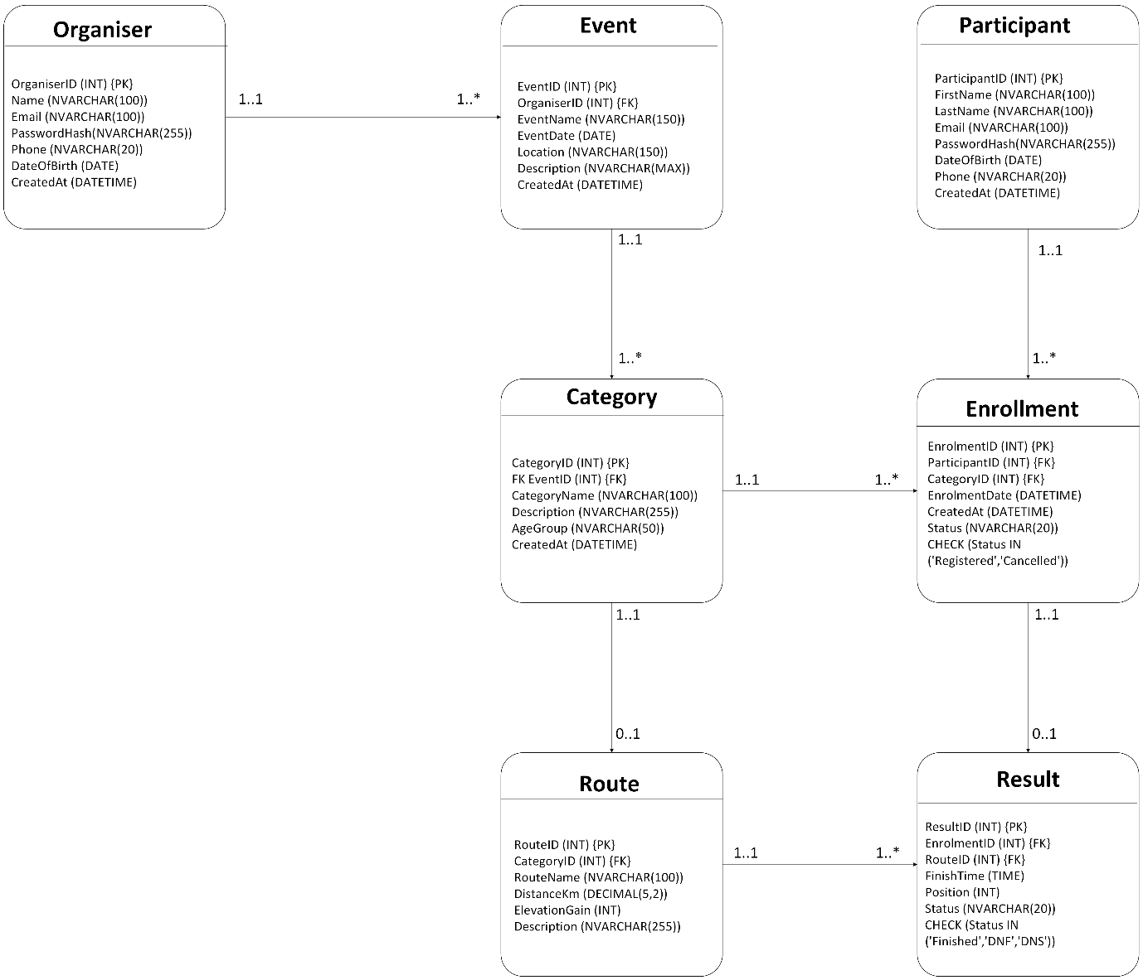
4.1 Explanation of the entities
Users: Stores both Organisers and Participants. The Role field identifies which type of account the user has. Email is unique so two accounts cannot use the same email address.
Categories: Stores the types of events, such as 5 KM, 10 KM and 21 KM. A category can be used by many events.
Routes: Stores route information such as distance, start location, finish location and elevation. A route can be linked to an event.
Events: Stores the main event information. Each event has one organiser, one category and one route in this design.
Enrollments: Connects Participants to Events. This is important because one participant can enter many events and one event can have many participants.
Results: Stores the finishing result for an enrolment. An enrolment can have zero or one result before the event is completed.
4.2 Relationship and cardinality decisions
- Users to Events: one Organiser can create many Events (1:M).
- Users to Enrollments: one Participant can have many Enrollments (1:M).
- Categories to Events: one Category can be used by many Events (1:M).
- Routes to Events: one Route can be linked to many Events in the current design (1:M).
- Events to Enrollments: one Event can have many Enrollments (1:M).
- Enrollments to Results: an Enrolment can have zero or one Result, while each Result belongs to exactly one Enrolment (1:0..1).
4.3 Why the design is useful
The Enrollments table is especially important because it solves the many-to-many relationship between Participants and Events. Instead of storing a list of participants inside the Events table, each enrolment is stored as its own record. This makes it possible to store extra information about the enrolment, such as the enrolment date, status and bib number.
The Results table is separate from Enrollments because a participant may enrol before the event happens. At that point there is no result yet. After the race, an organiser can add the finishing time and position. This makes the database match the real process instead of forcing result information to exist when a participant first enters an event.

5. REST API Endpoint Plan
The API is planned around resources such as users, events, categories, enrolments and results. Standard HTTP methods are used because they have clear meanings. GET is used to retrieve information, POST is used to create information, PUT is used to update a resource and DELETE is used to remove a resource (MDN Web Docs, 2025a).
So the API will return JSON. Successful creation will normally use 201 Created, normal successful requests will use 200 OK, and successful deletion can use 204 No Content (MDN Web Docs, 2025b).
The endpoint plan also considers security. The Participant should not be able to use an Organiser endpoint just because the endpoint is visible. Authorisation needs to be checked by the API itself. OWASP recommends access control at each protected REST endpoint (OWASP Foundation, 2026).
Method | Route | Description | Role | Request body | Expected response
POST | /api/auth/register | Create a new participant account. | Public | {"firstName":"Anele","lastName":"Mokoena","email":"anele@example.com","password":"***"} | 201 Created; user details and access token.
POST | /api/auth/login | Log a user in and return an access token. | Public | {"email":"anele@example.com","password":"***"} | 200 OK; token, user ID and role.
GET | /api/profile | Return the logged-in user's profile. | Participant / Organiser | None | 200 OK; profile details.
PUT | /api/profile | Update the logged-in user's profile. | Participant / Organiser | {"firstName":"Anele","lastName":"Mokoena"} | 200 OK; updated profile.
GET | /api/categories | List event categories. | Public | None | 200 OK; array of categories.
POST | /api/categories | Create a new event category. | Organiser | {"categoryName":"10 KM Road Race","description":"Road running event"} | 201 Created; category object.
PUT | /api/categories/{id} | Edit an event category. | Organiser | {"categoryName":"10 KM Run","description":"Updated description"} | 200 OK; updated category.
DELETE | /api/categories/{id} | Delete a category when it is not in use. | Organiser | None | 204 No Content; 404 if not found; 409 if still used.
GET | /api/events | List upcoming events, with optional category filter. | Public | Query: ?categoryId=1 | 200 OK; array of event summaries.
GET | /api/events/{id} | View one event and its route/category details. | Public | None | 200 OK; event details; 404 if not found.
POST | /api/events | Create a new event. | Organiser | {"eventName":"Pretoria Spring Run","eventDate":"2026-10-10","startTime":"07:00","location":"Pretoria","capacity":500,"categoryId":1,"routeId":1} | 201 Created; event object.
PUT | /api/events/{id} | Update an event owned by the organiser. | Organiser | {"eventName":"Pretoria Spring Run","capacity":550} | 200 OK; updated event.
DELETE | /api/events/{id} | Delete an event owned by the organiser. | Organiser | None | 204 No Content; 404 if not found.
GET | /api/events/{id}/enrolments | View all enrolments for an organiser's event. | Organiser | None | 200 OK; participant enrolment list.
POST | /api/events/{id}/enrolments | Enrol the logged-in participant in an event. | Participant | {"bibNumber":101} | 201 Created; enrolment object; 409 if already enrolled/full.
GET | /api/enrolments/me | View the logged-in participant's enrolments. | Participant | None | 200 OK; participant's enrolment list.
GET | /api/enrolments/{id} | View one enrolment belonging to the logged-in participant. | Participant | None | 200 OK; enrolment details; 403 if it belongs to another user.
DELETE | /api/enrolments/{id} | Cancel the logged-in participant's enrolment. | Participant | None | 204 No Content; 404 if not found.
GET | /api/results/me | View the logged-in participant's results. | Participant | None | 200 OK; result history.
POST | /api/enrolments/{id}/result | Record a result for an enrolment. | Organiser | {"finishTime":"01:02:34","position":12} | 201 Created; result object.
PUT | /api/results/{id} | Correct or update a recorded result. | Organiser | {"finishTime":"01:02:20","position":11} | 200 OK; updated result.
GET | /api/events/{id}/results | View results for an event. | Organiser | None | 200 OK; results ordered by position.

5.1 Important API rules
- Only Organisers can create, update or delete events and categories.
- Participants can only view and manage their own enrolments and personal results.
- An organiser can view enrolments for events that they manage.
- Duplicate enrolment of the same participant into the same event will be rejected.
- The API will validate that the requested event, category, route and user exist before saving related records.
- Error responses should be clear but should not expose passwords, password hashes or other unnecessary private information.

Section C
6. SQL Server Database Script
The SQL script in the submission package creates the RaceDayDB database and all six tables shown in the ERD. It includes primary keys, foreign keys, NOT NULL, UNIQUE, DEFAULT and CHECK constraints. These constraints are important because they stop obviously invalid data from being stored. SQL Server supports these constraint types directly in CREATE TABLE statements (Microsoft, 2026a).
The script also includes sample data with two Organisers, two Participants, three Events, three Categories, three Routes, sample Enrollments and sample Results. The sample records make it possible to test whether the relationships work before Part 2 is developed.
The full executable script is supplied separately as `docs/RaceDay.sql`. It is better to keep the full SQL in its own file because the assignment specifically requires a SQL file in the docs folder.

6.1 Main constraints used
Constraint | Example | Purpose
PRIMARY KEY | UserID, EventID, etc. | Uniquely identifies each record.
FOREIGN KEY | Events.OrganizerID -> Users.UserID | Keeps relationships between tables valid.
UNIQUE | Users.Email; ParticipantID + EventID | Prevents duplicate emails and duplicate enrolments.
NOT NULL | Names, email, event dates, keys | Makes required data compulsory.
DEFAULT | CreatedAt, Status, EnrollmentDate | Automatically supplies common values when none are given.
CHECK | Role, Status, Capacity, Position | Prevents values that do not make sense for the system.

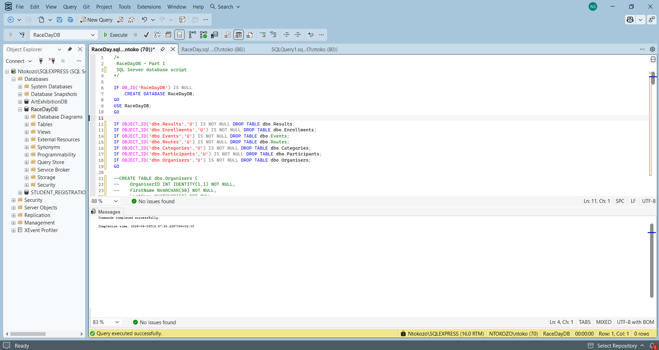
This screenshot shows the beginning of the SQL script. The script checks if the RaceDayDB database already exists using: IF DB_ID('RaceDayDB') IS NULL
If the database does not exist, it creates it using CREATE DATABASE RaceDayDB.
The script then uses: USE RaceDayDB
This tells SQL Server that the rest of the commands should be performed inside the RaceDay database. The script also starts preparing the database by checking whether the tables already exist. So basically the screenshot shows the creation and preparation of the RaceDayDB database. The script first checks whether the database already exists before creating it. The database is then selected using the USE statement so that the tables can be created inside RaceDayDB.

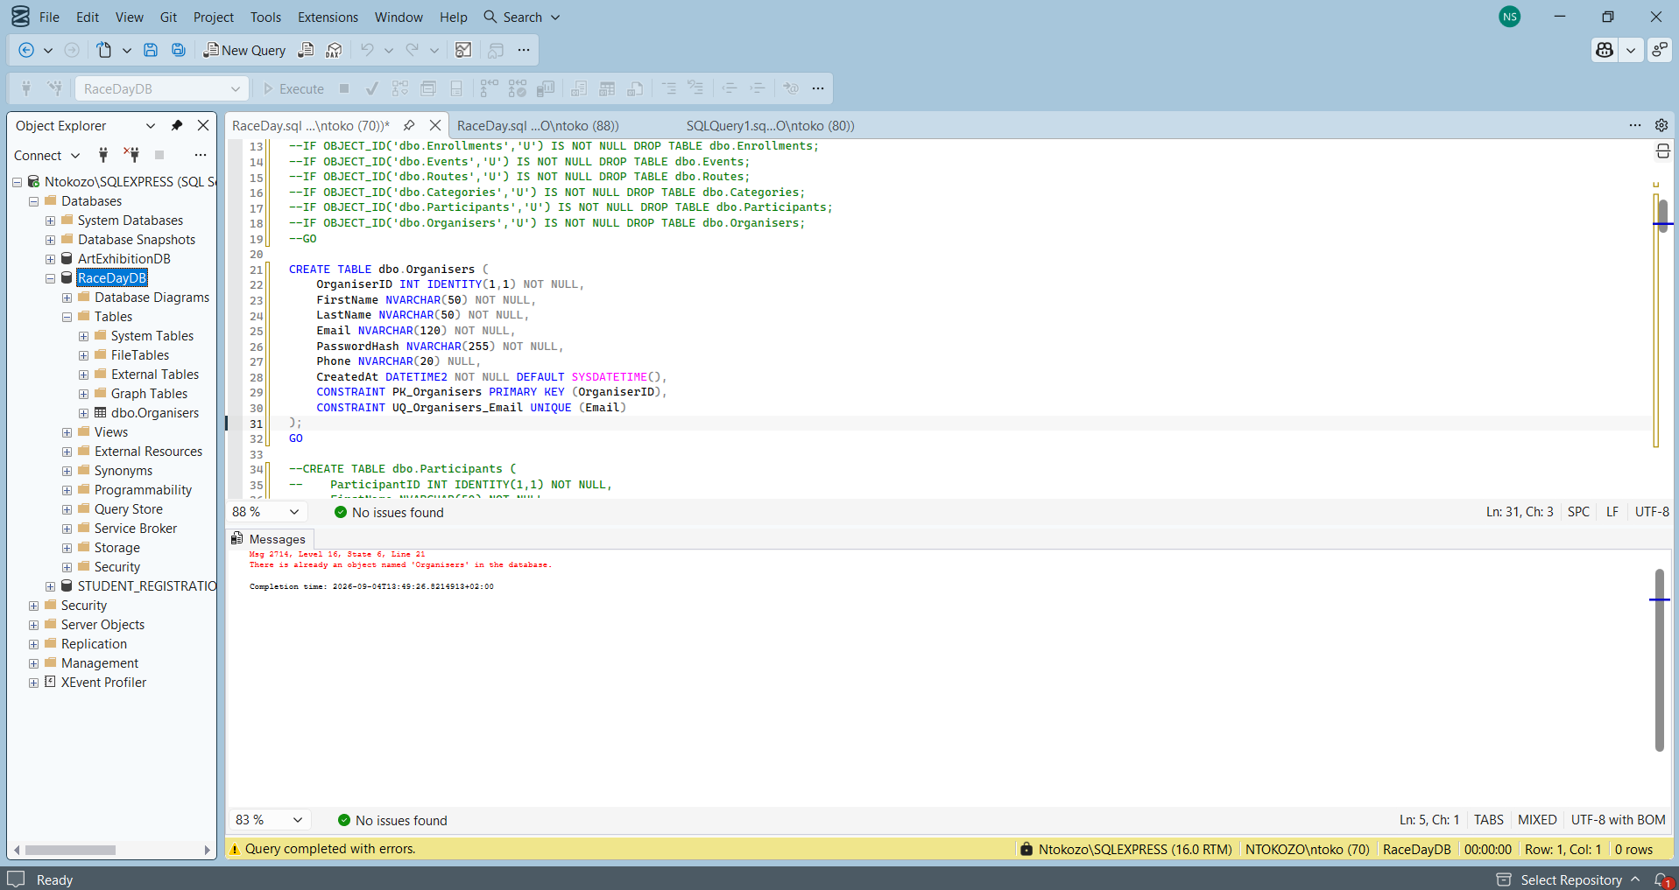
This screenshot shows the Organisers table being created. The table contains information about the people responsible for managing RaceDay events.
The main fields include:
- OrganiserID
- FirstName
- LastName
- Email
- PasswordHash
- Phone
- CreatedAt
OrganiserID is the primary key, meaning every organiser gets a unique ID. The email is also unique, which helps prevent two organiser accounts from using the same email address.
The screenshot also shows the Messages section reporting an issue saying that an object named Organisers already exists and because I had already ran the table it just that it was not visible in the object explore, disregard the warning.
This is because the table had already been created in the database when the command was run again. So the screenshot shows the creation of the Organisers table. The table stores the details of people who manage events. OrganiserID is used as the primary key and the email address is unique. The message at the bottom indicates that the table already existed when the command was executed again.

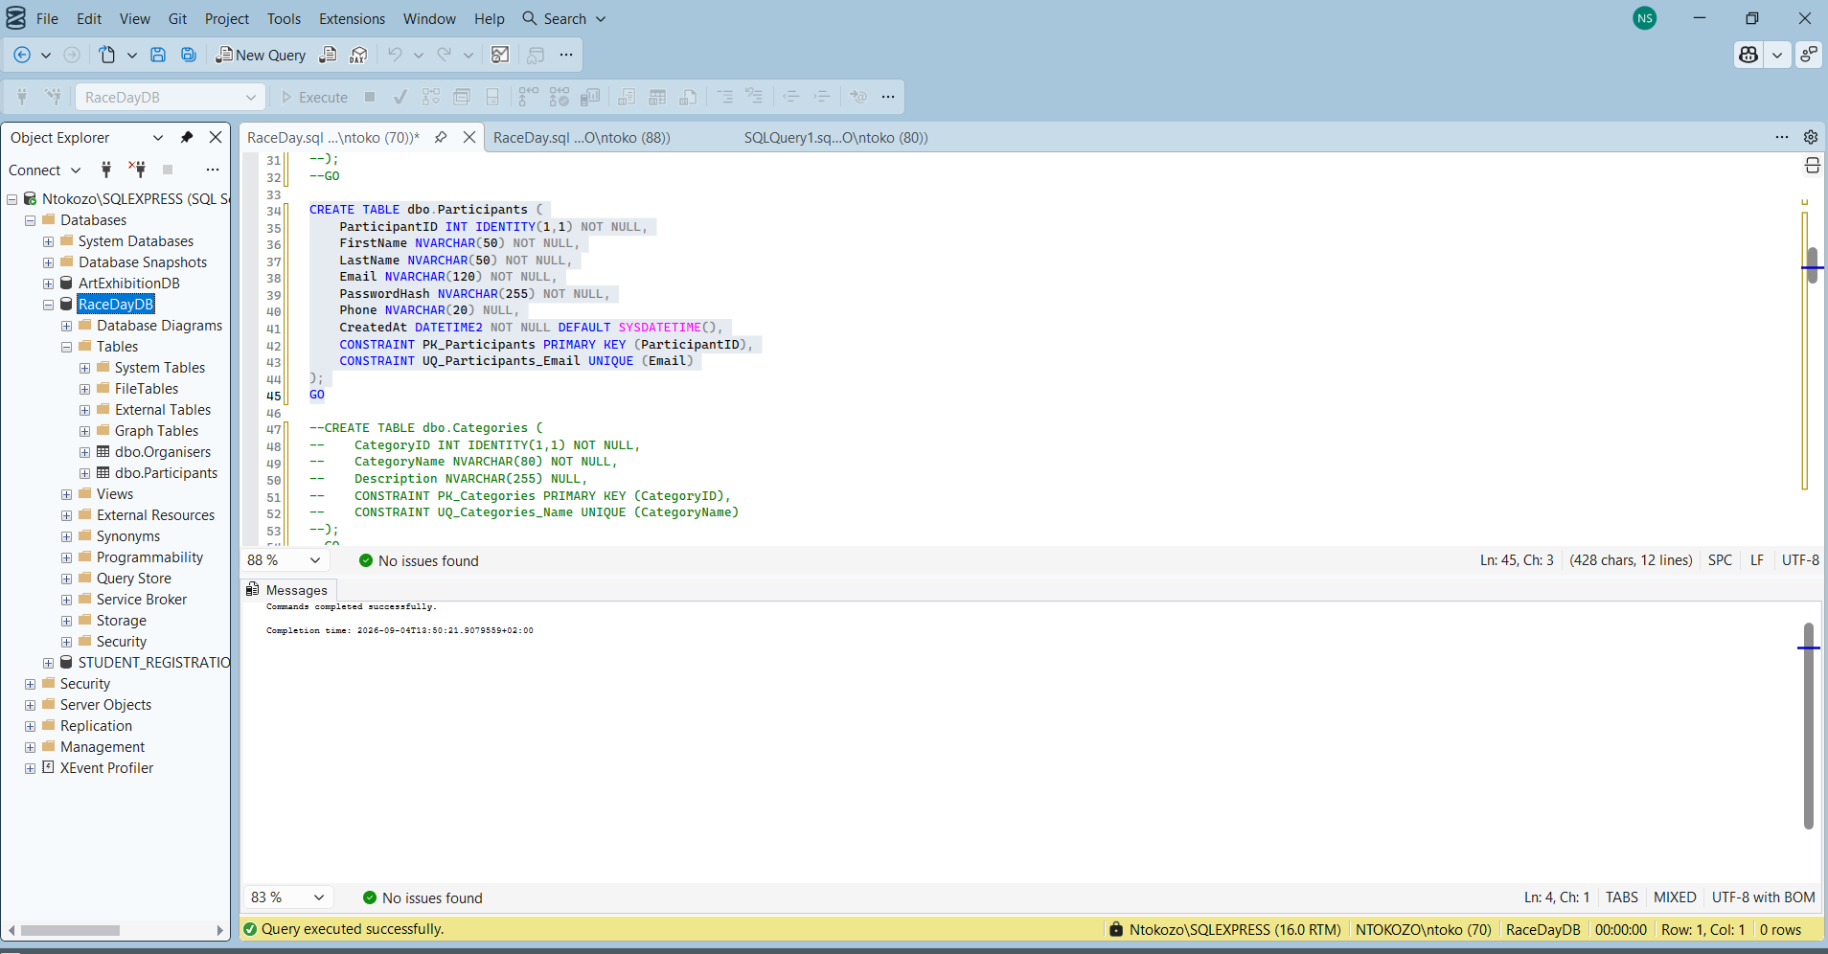
This screenshot shows the Participants table and the beginning of the Categories table.
The Participants table contains:
- ParticipantID
- FirstName
- LastName
- Email
- PasswordHash
- Phone
- CreatedAt
The ParticipantID is the primary key. The email address is also unique. This is important because Participants are kept in their own table, instead of putting them into a general Users table. The screenshot also begins creating the Categories table.
Categories will be used to describe the different types of events.
For example:
- 5 KM Fun Run
- 10 KM Road Race
- 21 KM Half Marathon
The Messages section says: Commands completed successfully. So this part of the script executed successfully. So the screenshot shows the creation of the Participants table and the Categories table. Participants are stored separately from Organisers, which follows the required database design. The Categories table is used to store the different types of races available in the system.

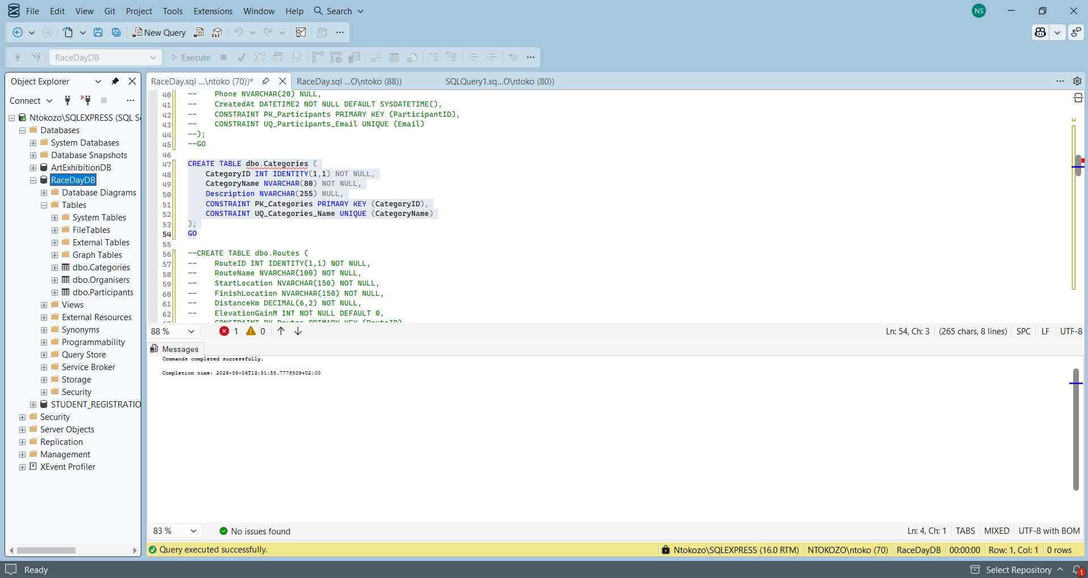
This screenshot continues with the database structure.
The Categories table has:
- CategoryID
- CategoryName
- Description
The CategoryID is the primary key and CategoryName is unique. The screenshot then starts the Routes table. The Routes table stores information about the route used by an event.
It includes:
- RouteID
- RouteName
- StartLocation
- FinishLocation
- DistanceKm
- ElevationGainM
For example, the distance could be 5.00 KM, while elevation gain could be 45 metres. The SQL command completed successfully. So the screenshot shows the creation of the Categories and Routes tables. Categories describe the type of event, while Routes store information about where the event starts and finishes, its distance and its elevation gain.

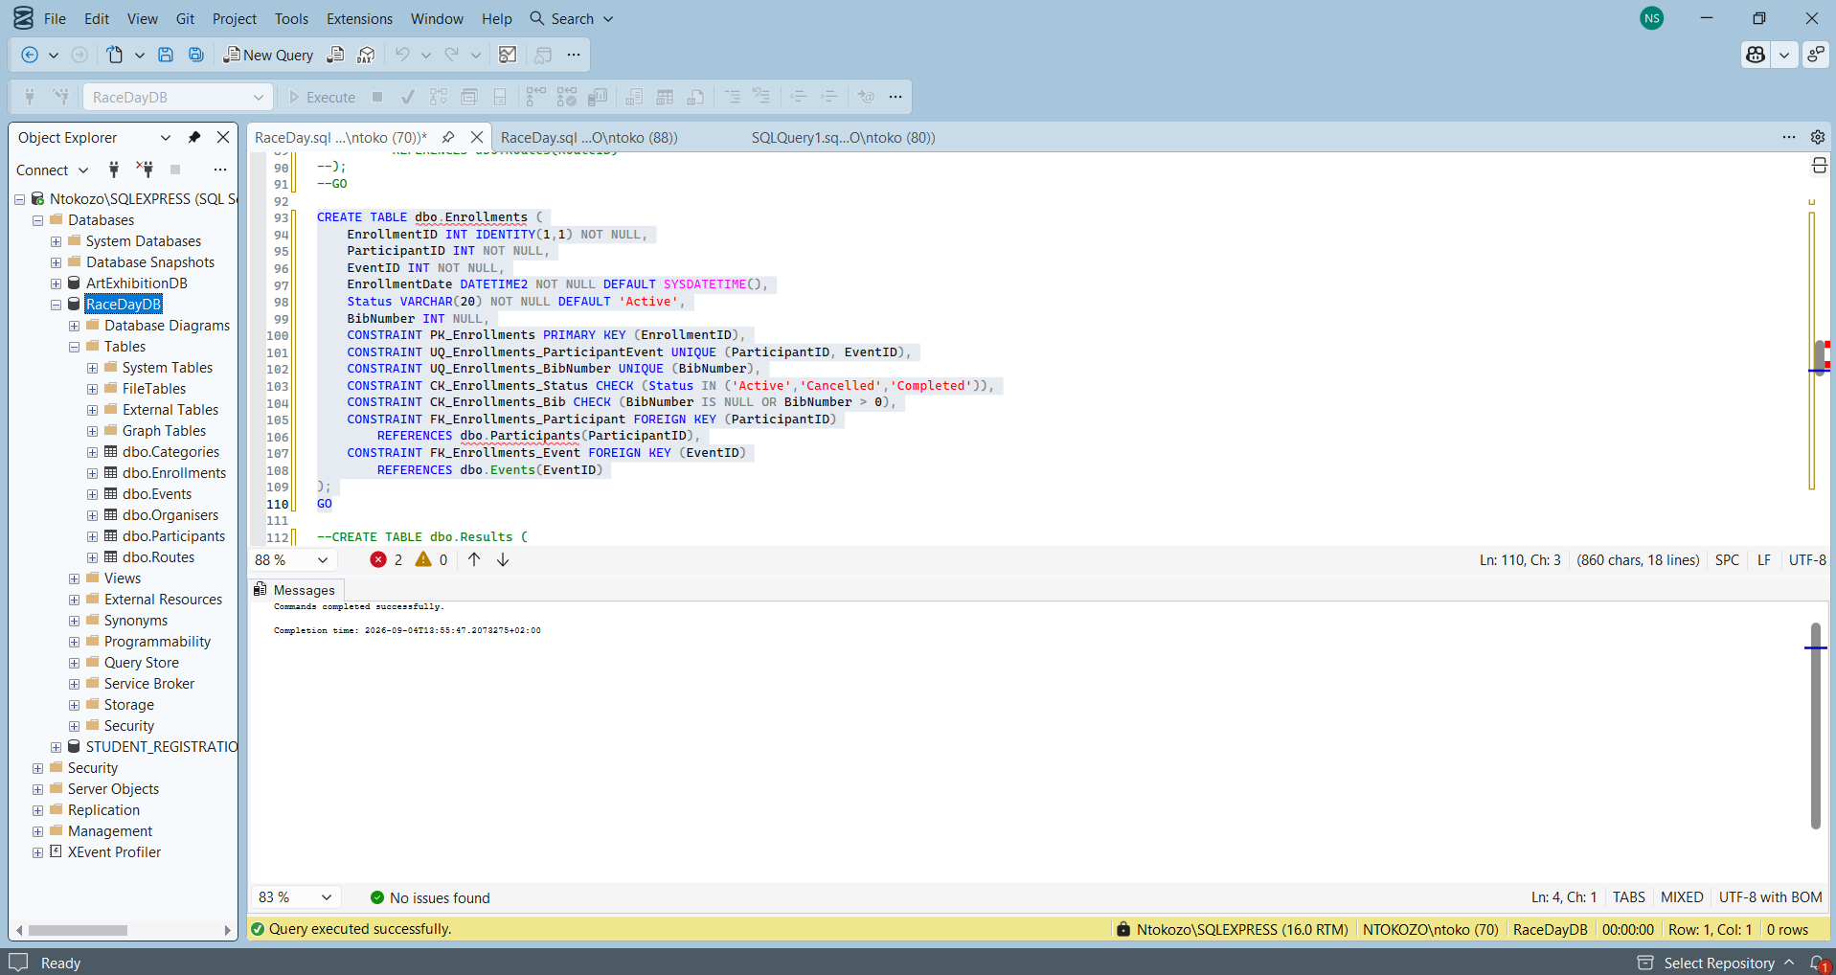
This screenshot shows the creation of the Enrollments table. This table is very important because it connects a Participant to an Event.
It contains:
- EnrollmentID
- ParticipantID
- EventID
- EnrollmentDate
- Status
- BibNumber
The table has a foreign key to:
Participants
and another foreign key to:
Events.
There is also:
UNIQUE (ParticipantID, EventID)
This prevents the same participant from entering the same event more than once.
The status can be:
- Active
- Cancelled
- Completed
This shows the creation of the Enrollments table. The table connects Participants with Events. Foreign keys are used to maintain the relationship between the tables, while the unique constraint prevents a participant from registering for the same event more than once.

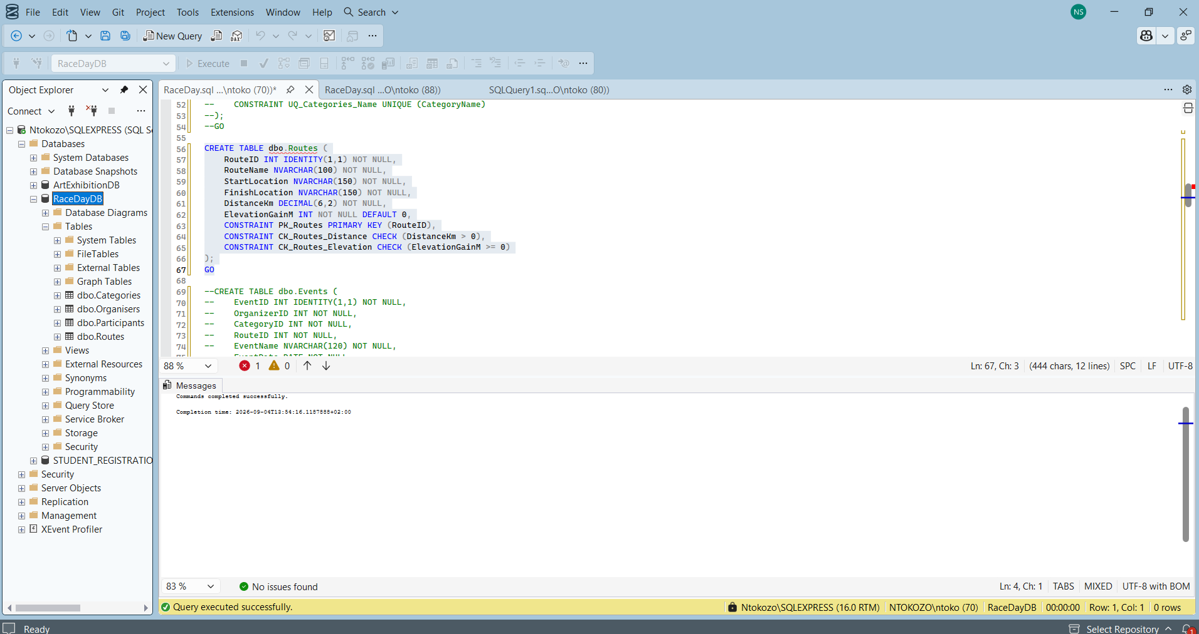
This screenshot continues with the Routes table. The script adds constraints such as: PRIMARY KEY (RouteID) and: CHECK (DistanceKm > 0)
The distance CHECK constraint makes sure that a route cannot have a distance of zero or a negative distance. There is also an elevation constraint to make sure the elevation value is not negative. The screenshot then starts creating the Events table.
The Events table contains:
- EventID
- OrganizerID
- CategoryID
- RouteID
- EventName
and other event information.
The important thing here is that the Events table uses foreign keys to connect an event to its organiser, category and route. This shows the constraints used for the Routes table and the beginning of the Events table. The CHECK constraints help prevent invalid route information. The Events table also contains foreign keys that will connect each event to an organiser, category and route.
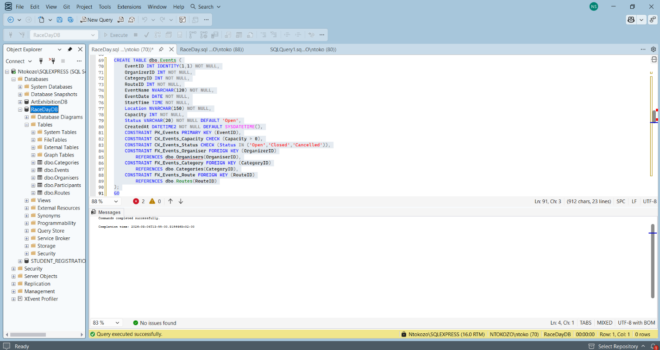
This screenshot shows the complete Events table.
Some of the important fields are:
- EventID
- OrganizerID
- CategoryID
- RouteID
- EventName
- EventDate
- StartTime
- Location
- Capacity
- Status
- CreatedAt
The foreign keys are especially important.
OrganizerID references:
dbo.Organisers(OrganiserID)
CategoryID references:
dbo.Categories(CategoryID)
RouteID references:
dbo.Routes(RouteID)
This means the Events table is connected to the other tables. There are also CHECK constraints for capacity and event status.

For example, the status can be:
- Open
- Closed
- Cancelled
The screenshot says Commands completed successfully. The screenshot shows completed Events table. The table contains the main information about each event and uses foreign keys to connect events with Organisers, Categories and Routes. CHECK constraints are also used to prevent invalid capacity and status values.
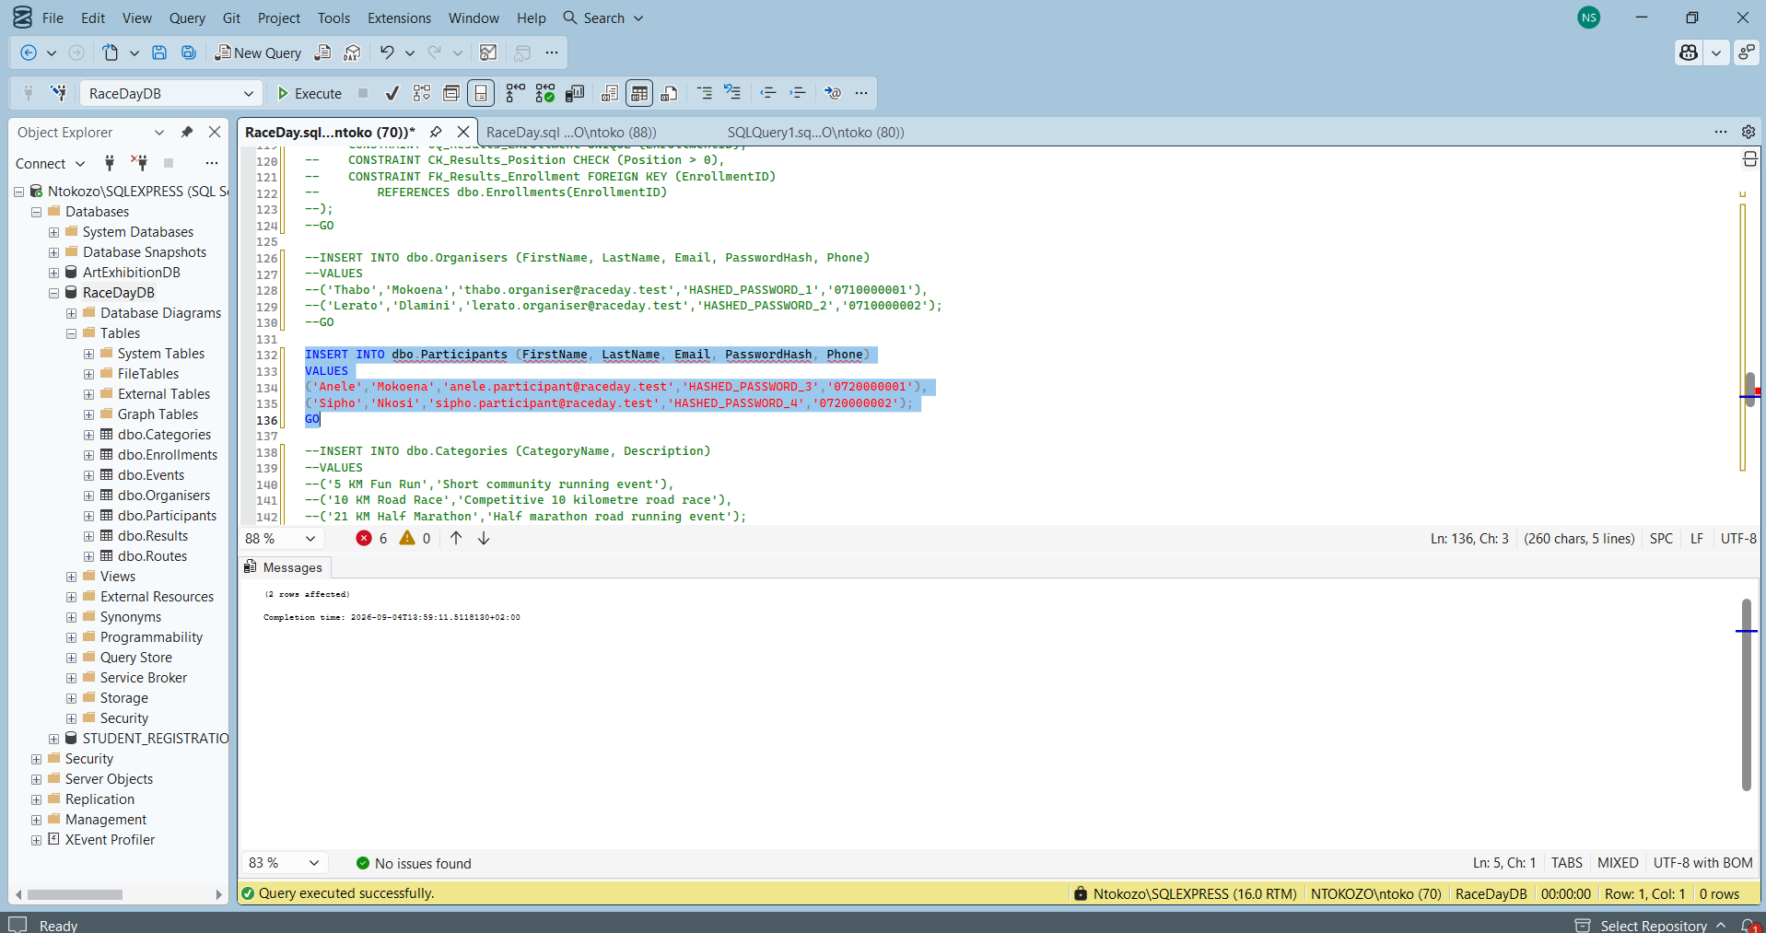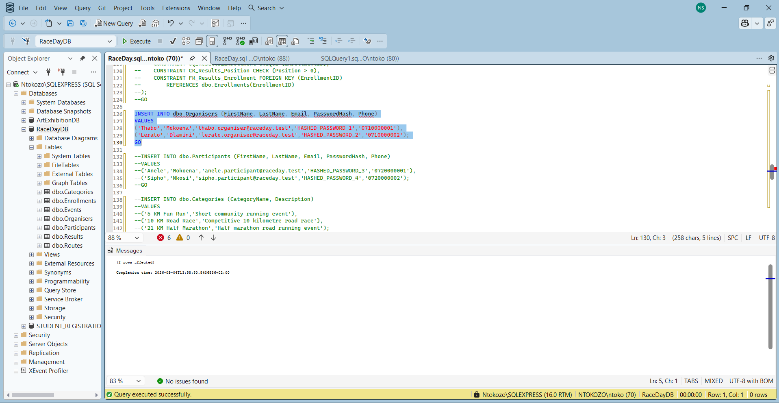
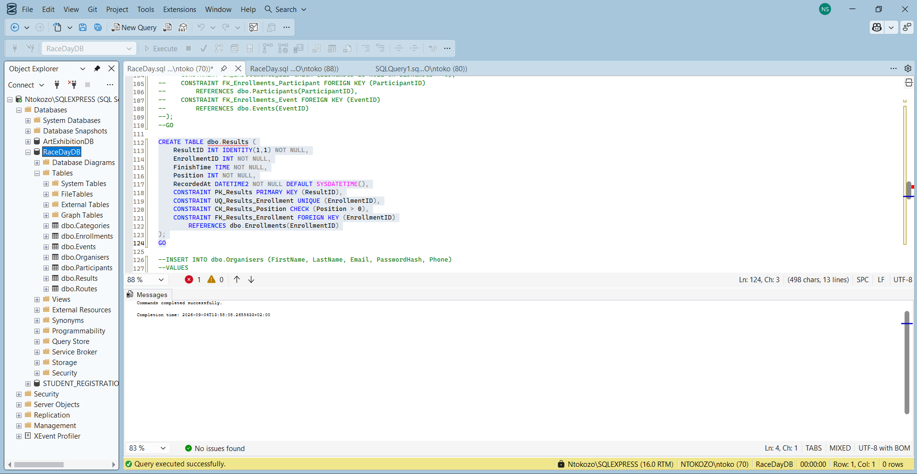
This screenshot shows the Results table being created.
The table contains:
- ResultID
- EnrollmentID
- FinishTime
- Position
- RecordedAt
The Results table is connected to the Enrollments table through EnrollmentID.
There is also:
UNIQUE (EnrollmentID)
This means one enrolment can only have one result.
There is also:
CHECK (Position > 0)
This makes sure that a finishing position cannot be zero or negative. This shows the creation of the Results table. The table stores the finishing time and position of participants. Each result is connected to an enrolment using EnrollmentID, and the CHECK constraint ensures that the finishing position is a positive number.

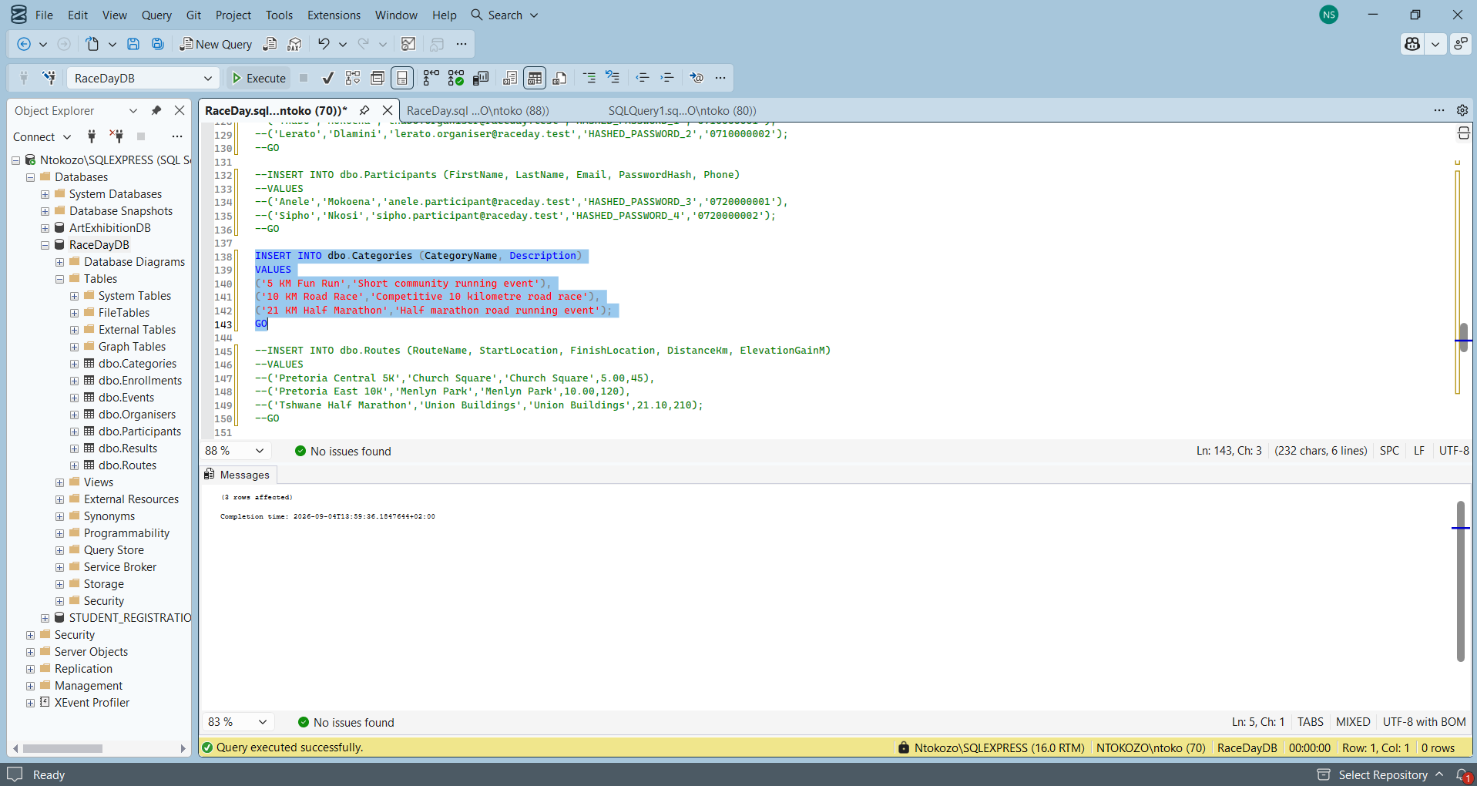
This screenshot starts adding sample data.
The categories include:
- 5 KM Fun Run
- 10 KM Road Race
- 21 KM Half Marathon
The Messages section shows 2 rows affected, confirming that two records were inserted for the relevant statement. This shows sample data being inserted into the Participants and Categories tables. Two participants are added and the race categories are also populated. This provides test data that can later be used to test the database relationships.

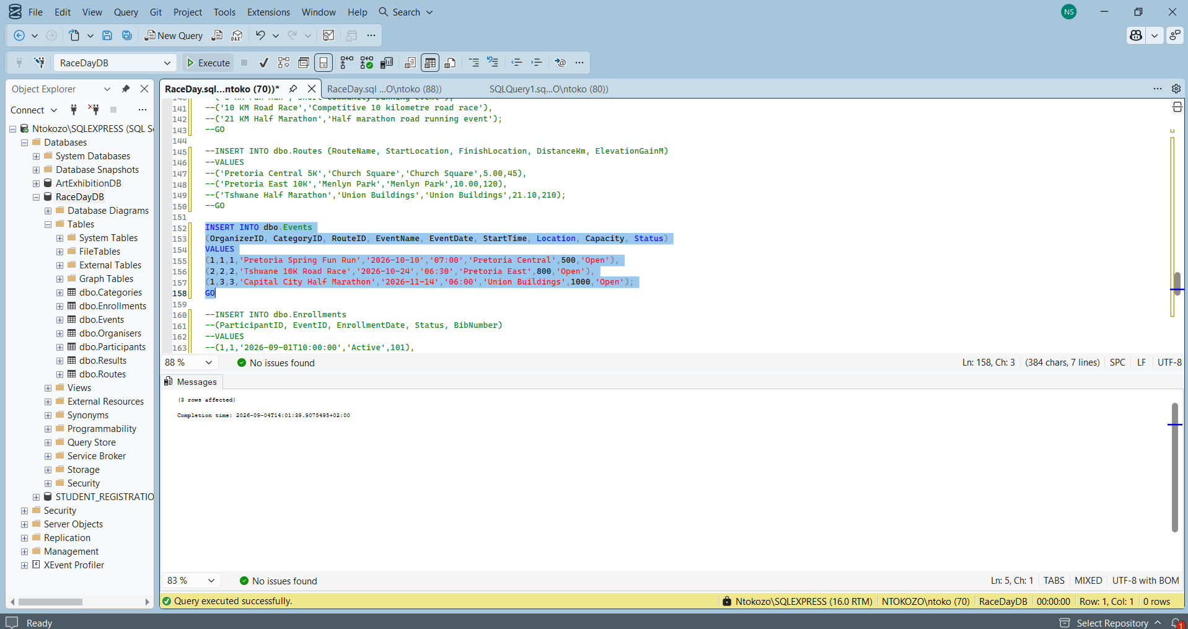
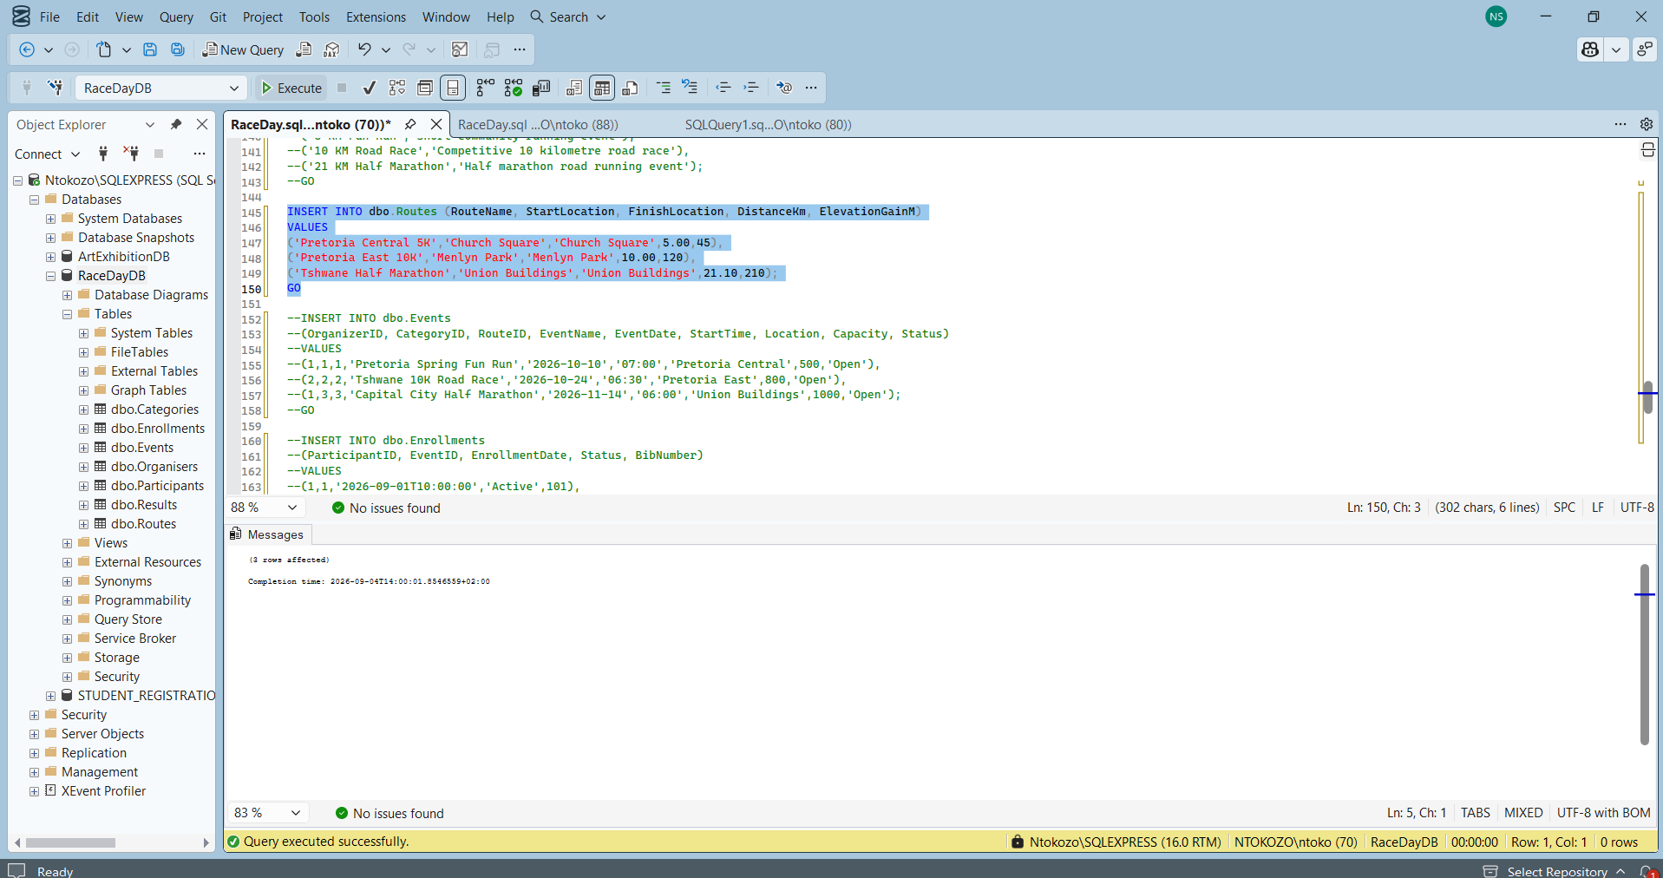
This screenshot continues with the sample data. It shows the two participants being inserted and then starts inserting data into the Routes table.
The three routes are:
Pretoria Central 5K
Start: Church Square
Finish: Church Square
Distance: 5 KM
Elevation: 45 M
Pretoria East 10K
Start: Menlyn Park
Finish: Menlyn Park
Distance: 10 KM
Elevation: 120 M
Tshwane Half Marathon
Start: Union Buildings
Finish: Union Buildings
Distance: 21.10 KM
Elevation: 210 M
So this shows the insertion of participant and route data. Three routes are added to the database with their starting location, finishing location, distance and elevation gain. This information will be used by the Events table.

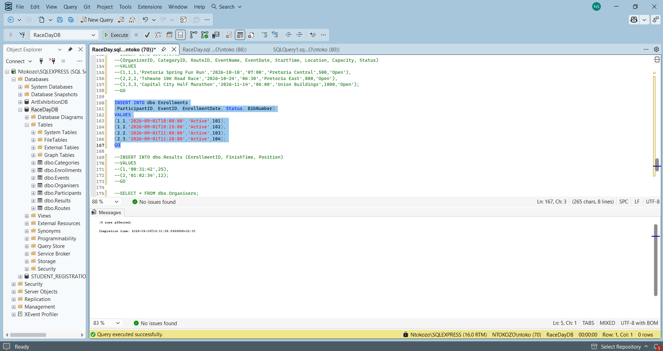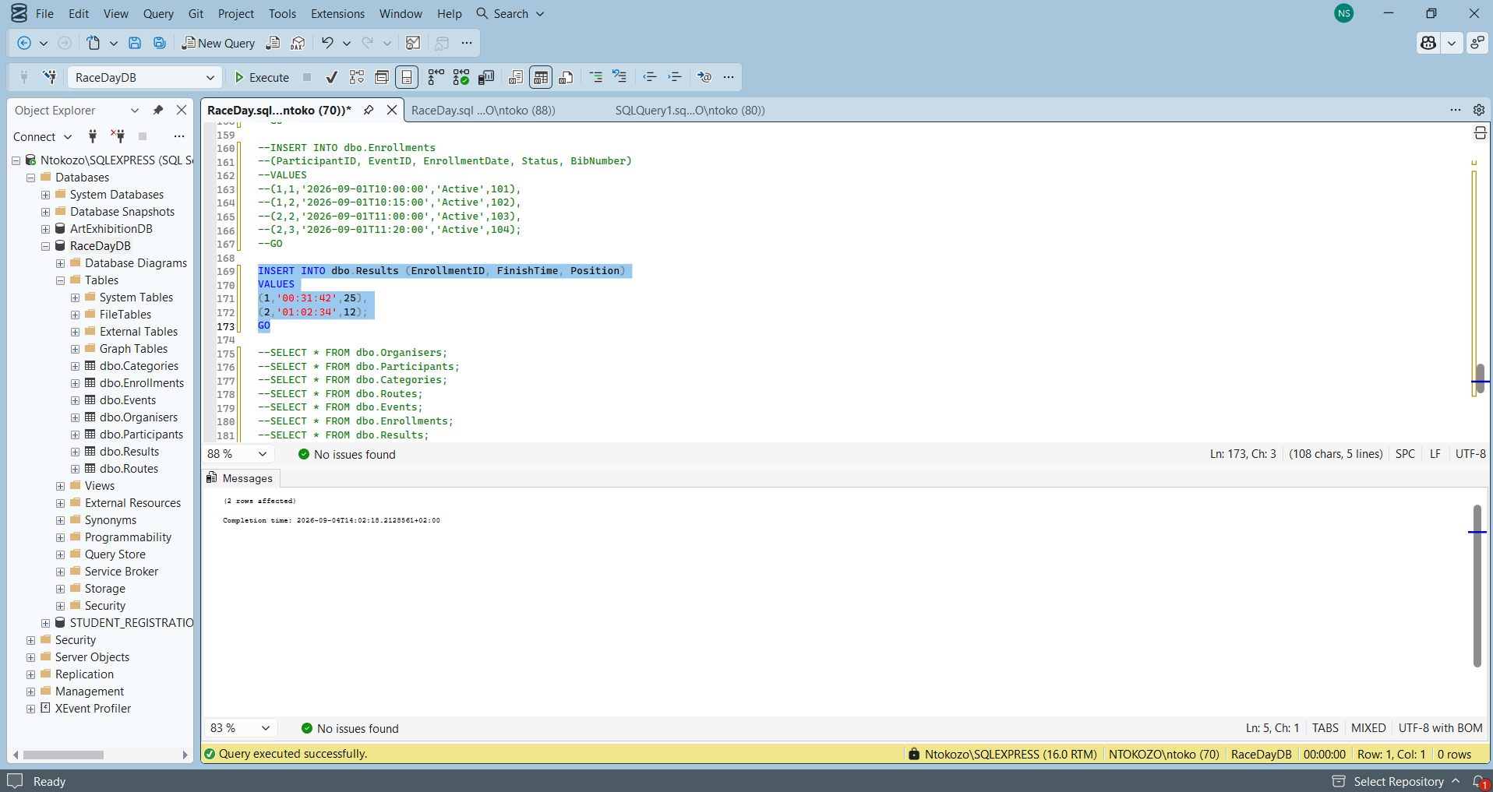This screenshot starts inserting event information.
The events are connected using:
- OrganizerID
- CategoryID
- RouteID
One of the events shown is:
Capital City Half Marathon
The event has:
- Date: 14 November 2026
- Start time: 06:00
- Location: Union Buildings
- Capacity: 1000
- Status: Open
The screenshot then starts the Enrollments data.It shows the insertion of event data. The events are linked to an organiser, category and route through their IDs. The screenshot also begins inserting participant enrolment information.

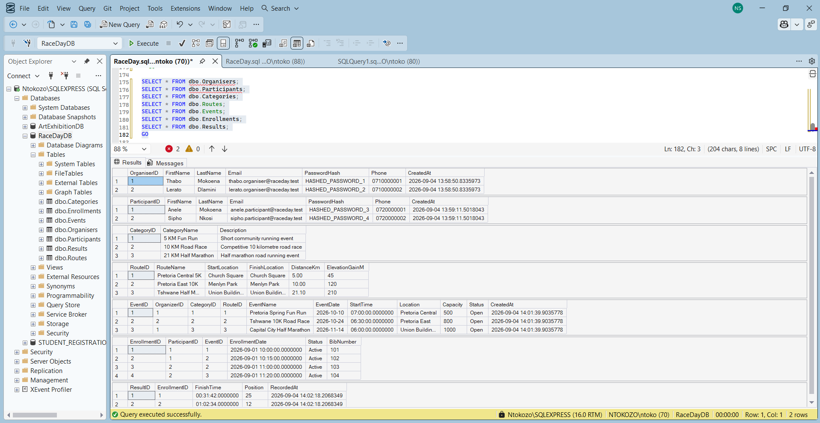
This shows the final results returned from the database after the SELECT statements were executed. The screenshot displays information from the main tables, including the Organisers, Participants, Categories, Routes, Events, Enrollments and Results. The data shows that the database has been populated successfully and that the different IDs are being used to connect the tables. For example, events are linked to organisers, categories and routes, while enrolments connect participants to events and results connect back to enrolments. This final screenshot provides evidence that the database structure and sample data are working together correctly.

Full Script for SQL:
IF DB_ID('RaceDayDB') IS NULL
CREATE DATABASE RaceDayDB;
GO
USE RaceDayDB;
GO

IF OBJECT_ID('dbo.Results','U') IS NOT NULL DROP TABLE dbo.Results;
IF OBJECT_ID('dbo.Enrollments','U') IS NOT NULL DROP TABLE dbo.Enrollments;
IF OBJECT_ID('dbo.Events','U') IS NOT NULL DROP TABLE dbo.Events;
IF OBJECT_ID('dbo.Routes','U') IS NOT NULL DROP TABLE dbo.Routes;
IF OBJECT_ID('dbo.Categories','U') IS NOT NULL DROP TABLE dbo.Categories;
IF OBJECT_ID('dbo.Participants','U') IS NOT NULL DROP TABLE dbo.Participants;
IF OBJECT_ID('dbo.Organisers','U') IS NOT NULL DROP TABLE dbo.Organisers;
GO

CREATE TABLE dbo.Organisers (
OrganiserID INT IDENTITY(1,1) NOT NULL,
FirstName NVARCHAR(50) NOT NULL,
LastName NVARCHAR(50) NOT NULL,
Email NVARCHAR(120) NOT NULL,
PasswordHash NVARCHAR(255) NOT NULL,
Phone NVARCHAR(20) NULL,
CreatedAt DATETIME2 NOT NULL DEFAULT SYSDATETIME(),
CONSTRAINT PK_Organisers PRIMARY KEY (OrganiserID),
CONSTRAINT UQ_Organisers_Email UNIQUE (Email)
);
GO

CREATE TABLE dbo.Participants (
ParticipantID INT IDENTITY(1,1) NOT NULL,
FirstName NVARCHAR(50) NOT NULL,
LastName NVARCHAR(50) NOT NULL,
Email NVARCHAR(120) NOT NULL,
PasswordHash NVARCHAR(255) NOT NULL,
Phone NVARCHAR(20) NULL,
CreatedAt DATETIME2 NOT NULL DEFAULT SYSDATETIME(),
CONSTRAINT PK_Participants PRIMARY KEY (ParticipantID),
CONSTRAINT UQ_Participants_Email UNIQUE (Email)
);
GO

CREATE TABLE dbo.Categories (
CategoryID INT IDENTITY(1,1) NOT NULL,
CategoryName NVARCHAR(80) NOT NULL,
Description NVARCHAR(255) NULL,
CONSTRAINT PK_Categories PRIMARY KEY (CategoryID),
CONSTRAINT UQ_Categories_Name UNIQUE (CategoryName)
);
GO

CREATE TABLE dbo.Routes (
RouteID INT IDENTITY(1,1) NOT NULL,
RouteName NVARCHAR(100) NOT NULL,
StartLocation NVARCHAR(150) NOT NULL,
FinishLocation NVARCHAR(150) NOT NULL,
DistanceKm DECIMAL(6,2) NOT NULL,
ElevationGainM INT NOT NULL DEFAULT 0,
CONSTRAINT PK_Routes PRIMARY KEY (RouteID),
CONSTRAINT CK_Routes_Distance CHECK (DistanceKm > 0),
CONSTRAINT CK_Routes_Elevation CHECK (ElevationGainM >= 0)
);
GO

CREATE TABLE dbo.Events (
EventID INT IDENTITY(1,1) NOT NULL,
OrganizerID INT NOT NULL,
CategoryID INT NOT NULL,
RouteID INT NOT NULL,
EventName NVARCHAR(120) NOT NULL,
EventDate DATE NOT NULL,
StartTime TIME NOT NULL,
Location NVARCHAR(150) NOT NULL,
Capacity INT NOT NULL,
Status VARCHAR(20) NOT NULL DEFAULT 'Open',
CreatedAt DATETIME2 NOT NULL DEFAULT SYSDATETIME(),
CONSTRAINT PK_Events PRIMARY KEY (EventID),
CONSTRAINT CK_Events_Capacity CHECK (Capacity > 0),
CONSTRAINT CK_Events_Status CHECK (Status IN ('Open','Closed','Cancelled')),
CONSTRAINT FK_Events_Organiser FOREIGN KEY (OrganizerID)
REFERENCES dbo.Organisers(OrganiserID),
CONSTRAINT FK_Events_Category FOREIGN KEY (CategoryID)
REFERENCES dbo.Categories(CategoryID),
CONSTRAINT FK_Events_Route FOREIGN KEY (RouteID)
REFERENCES dbo.Routes(RouteID)
);
GO

CREATE TABLE dbo.Enrollments (
EnrollmentID INT IDENTITY(1,1) NOT NULL,
ParticipantID INT NOT NULL,
EventID INT NOT NULL,
EnrollmentDate DATETIME2 NOT NULL DEFAULT SYSDATETIME(),
Status VARCHAR(20) NOT NULL DEFAULT 'Active',
BibNumber INT NULL,
CONSTRAINT PK_Enrollments PRIMARY KEY (EnrollmentID),
CONSTRAINT UQ_Enrollments_ParticipantEvent UNIQUE (ParticipantID, EventID),
CONSTRAINT UQ_Enrollments_BibNumber UNIQUE (BibNumber),
CONSTRAINT CK_Enrollments_Status CHECK (Status IN ('Active','Cancelled','Completed')),
CONSTRAINT CK_Enrollments_Bib CHECK (BibNumber IS NULL OR BibNumber > 0),
CONSTRAINT FK_Enrollments_Participant FOREIGN KEY (ParticipantID)
REFERENCES dbo.Participants(ParticipantID),
CONSTRAINT FK_Enrollments_Event FOREIGN KEY (EventID)
REFERENCES dbo.Events(EventID)
);
GO

CREATE TABLE dbo.Results (
ResultID INT IDENTITY(1,1) NOT NULL,
EnrollmentID INT NOT NULL,
FinishTime TIME NOT NULL,
Position INT NOT NULL,
RecordedAt DATETIME2 NOT NULL DEFAULT SYSDATETIME(),
CONSTRAINT PK_Results PRIMARY KEY (ResultID),
CONSTRAINT UQ_Results_Enrollment UNIQUE (EnrollmentID),
CONSTRAINT CK_Results_Position CHECK (Position > 0),
CONSTRAINT FK_Results_Enrollment FOREIGN KEY (EnrollmentID)
REFERENCES dbo.Enrollments(EnrollmentID)
);
GO

INSERT INTO dbo.Organisers (FirstName, LastName, Email, PasswordHash, Phone)
VALUES
('Thabo','Mokoena','thabo.organiser@raceday.test','HASHED_PASSWORD_1','0710000001'),
('Lerato','Dlamini','lerato.organiser@raceday.test','HASHED_PASSWORD_2','0710000002');
GO

INSERT INTO dbo.Participants (FirstName, LastName, Email, PasswordHash, Phone)
VALUES
('Anele','Mokoena','anele.participant@raceday.test','HASHED_PASSWORD_3','0720000001'),
('Sipho','Nkosi','sipho.participant@raceday.test','HASHED_PASSWORD_4','0720000002');
GO

INSERT INTO dbo.Categories (CategoryName, Description)
VALUES
('5 KM Fun Run','Short community running event'),
('10 KM Road Race','Competitive 10 kilometre road race'),
('21 KM Half Marathon','Half marathon road running event');
GO

INSERT INTO dbo.Routes (RouteName, StartLocation, FinishLocation, DistanceKm, ElevationGainM)
VALUES
('Pretoria Central 5K','Church Square','Church Square',5.00,45),
('Pretoria East 10K','Menlyn Park','Menlyn Park',10.00,120),
('Tshwane Half Marathon','Union Buildings','Union Buildings',21.10,210);
GO

INSERT INTO dbo.Events
(OrganizerID, CategoryID, RouteID, EventName, EventDate, StartTime, Location, Capacity, Status)
VALUES
(1,1,1,'Pretoria Spring Fun Run','2026-10-10','07:00','Pretoria Central',500,'Open'),
(2,2,2,'Tshwane 10K Road Race','2026-10-24','06:30','Pretoria East',800,'Open'),
(1,3,3,'Capital City Half Marathon','2026-11-14','06:00','Union Buildings',1000,'Open');
GO

INSERT INTO dbo.Enrollments
(ParticipantID, EventID, EnrollmentDate, Status, BibNumber)
VALUES
(1,1,'2026-09-01T10:00:00','Active',101),
(1,2,'2026-09-01T10:15:00','Active',102),
(2,2,'2026-09-01T11:00:00','Active',103),
(2,3,'2026-09-01T11:20:00','Active',104);
GO

INSERT INTO dbo.Results (EnrollmentID, FinishTime, Position)
VALUES
(1,'00:31:42',25),
(2,'01:02:34',12);
GO

SELECT * FROM dbo.Organisers;
SELECT * FROM dbo.Participants;
SELECT * FROM dbo.Categories;
SELECT * FROM dbo.Routes;
SELECT * FROM dbo.Events;
SELECT * FROM dbo.Enrollments;
SELECT * FROM dbo.Results;
GO

9. Conclusion
Overall, the RaceDay plan gives a clear starting point for Part 2. The ERD identifies the main data that the system needs, the endpoint plan explains how the application will communicate with the API, and the SQL script turns the database design into an actual SQL Server database. The design also includes role-based access, validation rules and sample data so that the system can be tested properly.
I think this planning stage is useful because it makes the later coding stage more straightforward. Instead of deciding table names, relationships and API routes while coding, the main decisions have already been written down. The next step will be to build the ASP.NET REST API according to this plan and make sure that the implementation does not change the design without a clear reason.

10. References
Connolly, T. and Begg, C. (2015) Database Systems: A Practical Approach to Design, Implementation, and Management. 6th edn. Harlow: Pearson Education.
GitHub (2026) Workflows. Available at: https://docs.github.com/en/actions/concepts/workflows-and-actions/workflows (Accessed: 3 September 2026).
MDN Web Docs (2025a) HTTP request methods. Available at: https://developer.mozilla.org/en-US/docs/Web/HTTP/Reference/Methods (Accessed: 3 September 2026).
MDN Web Docs (2025b) HTTP response status codes. Available at: https://developer.mozilla.org/en-US/docs/Web/HTTP/Reference/Status (Accessed: 3 September 2026).
Microsoft (2026a) CREATE TABLE (Transact-SQL). Available at: https://learn.microsoft.com/en-us/sql/t-sql/statements/create-table-transact-sql (Accessed: 3 September 2026).
Microsoft (2026b) Primary and foreign key constraints. Available at: https://learn.microsoft.com/en-us/sql/relational-databases/tables/primary-and-foreign-key-constraints (Accessed: 3 September 2026).
OWASP Foundation (2026) REST Security Cheat Sheet. Available at: https://cheatsheetseries.owasp.org/cheatsheets/REST_Security_Cheat_Sheet.html (Accessed: 3 September 2026).
Sommerville, I. (2016) Software Engineering. 10th edn. Harlow: Pearson Education.

